IVLE Hangout - User Interface Design

### Features of IVLE Hangout

1. Drawing and Saving of Canvas
   1. Multiple tools
   2. Multiple colors
   3. Multiple sizes
   4. Sync across users
2. Document Repository for channels
   1. Uploading of documents
   2. Downloading of documents
   3. Retrieve of directory information
3. Logging of chat history
4. Public/Private chat room (channel)
   1. Chat among users
   2. Emoticons for chat
5. Private chatting between 2 users
6. User management
   1. Customisable nickname
   2. Mute list
   3. Autojoin (channel) preferences
   4. Status (Available, Away, Busy)
7. Channel management
   1. Registration of Channel
   2. Invite users to channel
   3. Kick users
   4. Change channel Topic
   5. Set Channel Privacy
   6. Set access levels of users in channel
   7. Set permissions levels of channel
8. Searching of users and channels

### The Login Phrase

In order to use IVLE Hangout system, user has to login using their IVLE ID.

1. Highlighted in **red** is the “Login!” button for user to click in order to authenticate himself with IVLE to use the IVLE Hangout system.

Figure

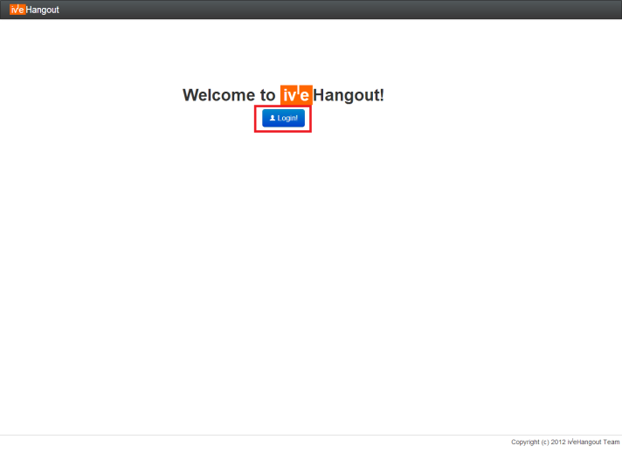

### The Dashboard - Overview

Upon successful login, user will be bought to our dashboard as shown.

1. Highlighted in **red** is a button for user to change their nickname, views their personal details or look up for help with other available command in IVLE Hangout
2. Highlighted in **blue** is the list of default channels that the user will join upon login. It is also define to be their favourite channel. Notice that there is a “**+**” beside the channel name, it define that the channel is **public**. On the other hand, a **private** channel will have a “**-**“ beside its channel name.
3. Highlighted in **yellow** is some action that the user can perform in order to create a channel with a single user (private chat) or with a group of user. Details about each action will be further explained in the next few sections.

Figure

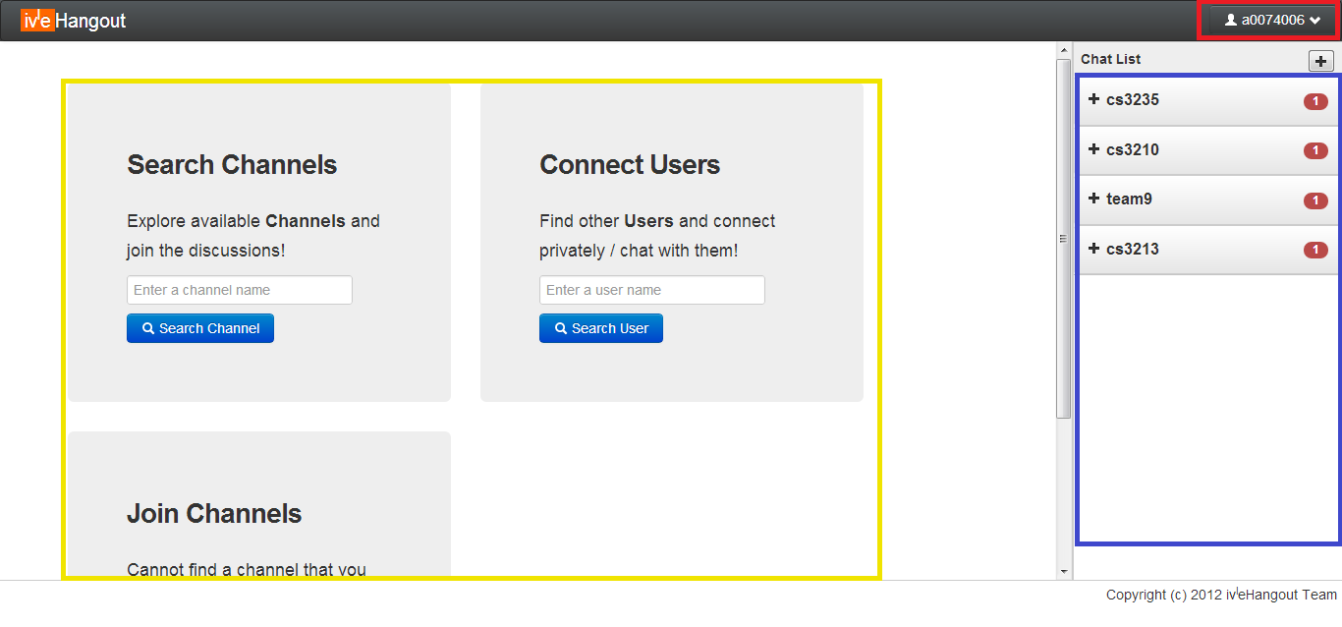

### The Dashboard – Search Channel

A user can search for available channel to join by typing a substring of the channel name in the “Search Channels” field.

1. Highlighted in **red** is the result of the search if it exists.
2. If a user attempt to join a channel that he/she is already in highlighted in **blue**, a notice to indicate that the user is already in the channel.
3. For example the channel that the user wish to join is highlighted in **yellow**, the user can simply click on the “Join” button to enter the channel. A notice to indicate that the action is successful will be shown in **Figure 4**.

Figure

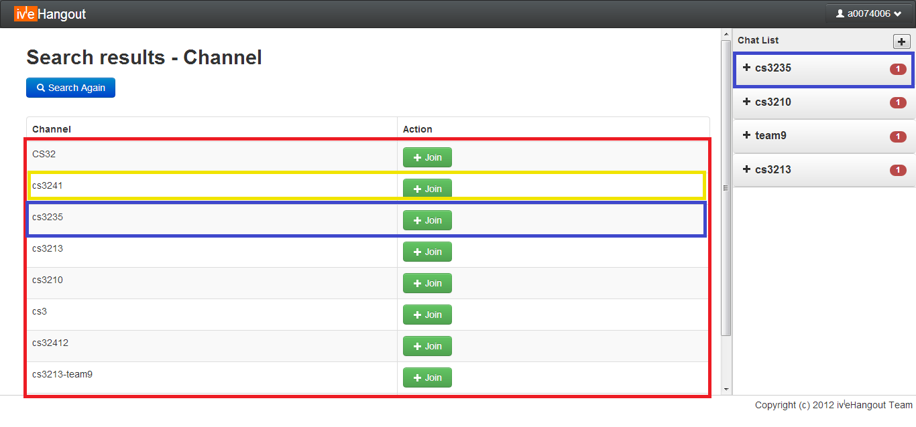

Figure

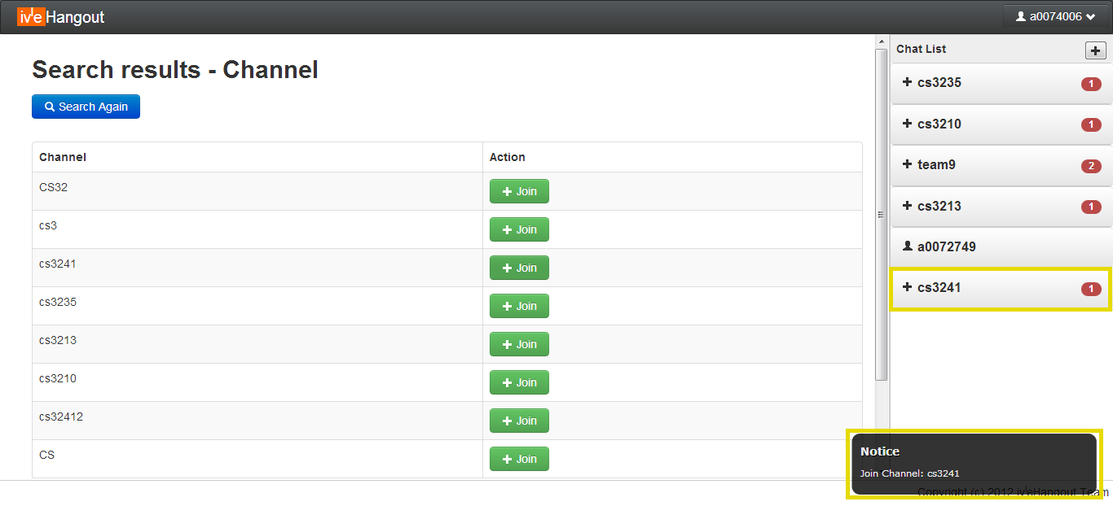

### The Dashboard – Connect User

A user can search for other users by its name, IVLE ID and nickname in the “Connect Users” field.

1. Highlighted in **red** is the search result if it exists in **Figure 5**.
2. If a user attempt to private chat with another user that is currently **offline** as highlighted in **blue**, a notice to indicate that user is offline will be shown in **Figure 6**.
3. If a user attempt to private chat with another user that is currently **online** as highlighted in **yellow**, simply click on the “Chat” button to initial the private chat. A new channel will be created with the user as shown in **Figure 7**. Note that private chat the icon is a human like shape.

Figure

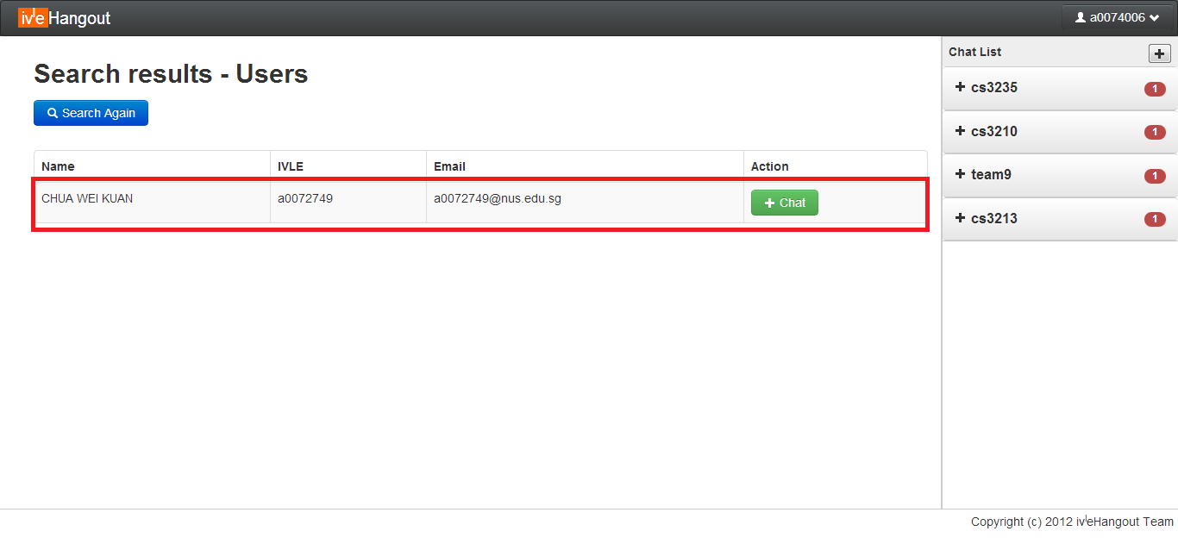

Figure

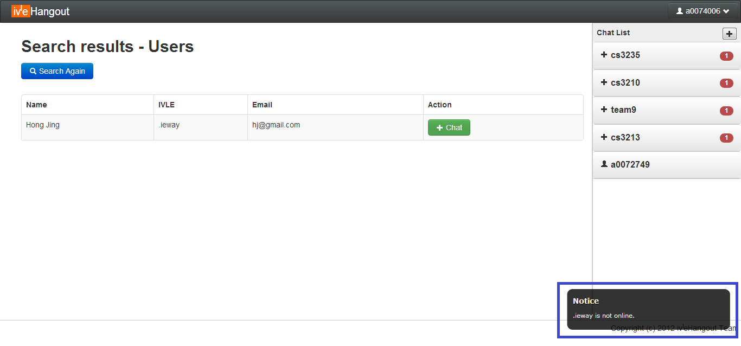

Figure

### 

### The Dashboard – Create Channels

A user can create a channel that does not exist yet but filling the desire channel name in the “Create Channels” field. A notification will be shown in **Figure 8** (Highlighted in **red**) to indicate the successful creation of channel. If a user attempt to create a channel that already exist and he/she is in the channel, error notification message will be shown. On the other hand, if a user attempt to create a channel that already exists but he/she is **not** in the channel, the user will be automatically set to join the channel as shown in **Figure 4.**

Figure

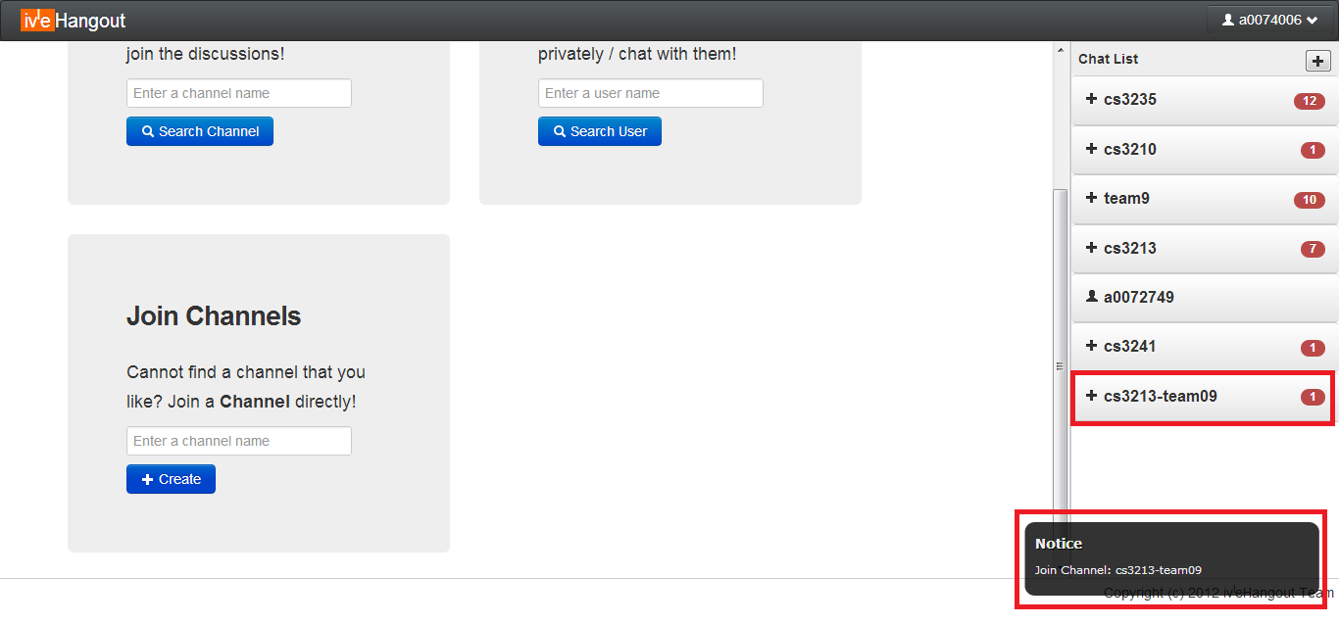

### The Dashboard – User’s Profile

If the user clicks on the top right button that displays his/her IVLE ID, a dropdown as shown in **Figure 9** will be shown.

1. Highlighted in **red** are the details pertaining to the user.
2. Highlighted in **yellow** is the user’s **nickname** and can be change by double clicking on the nickname.
3. Highlighted in **green** is the “Logout” button to logout from IVLE Hangout system as well as a “Help” button to display other available command that a user can use.

Figure

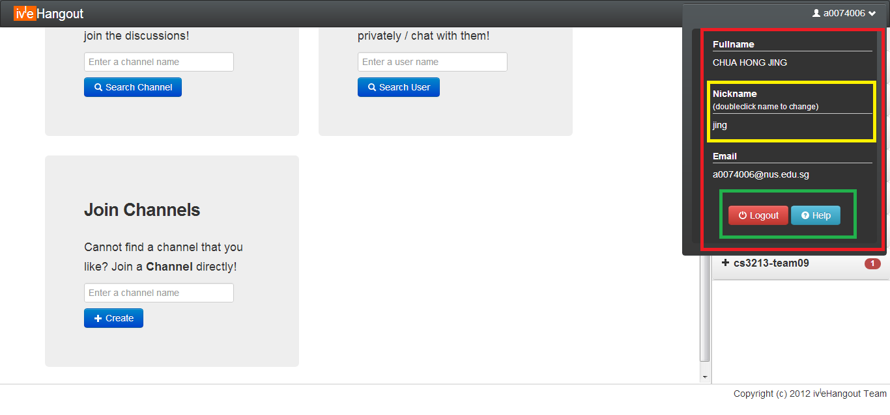

### The Dashboard – Where The Chat Begin

As shown in **Figure 10** is the overview of the chat area.

1. Highlighted in **red** is where the chat message will be displayed. Each chat message consist of 3 component namely the sender’s nickname, the message as well as the time the message is send.
2. Highlighted in **orange** is where the user will type his/her chat message.
3. Highlighted in **yellow** is the list of user(s) that is currently in the selected channel. The currently selected channel will have its channel name at the top left hand corner.
4. Highlighted in **green** will show the number of **unread** messages for that particular channel. E.g. there are **two** **unread** messages in channel “team9” and “cs3235”.
5. Highlighted in **blue** is the icon for actions that can be perform other than sending chat messages. **Starting** **from** **left**, the icon uniquely identify to be “**Drawing Canvas**”, “**Files**”, “**Settings**”, “**Favourite**”, “**Archive**”, “**Close**”, “**Channel User List**”.

Figure

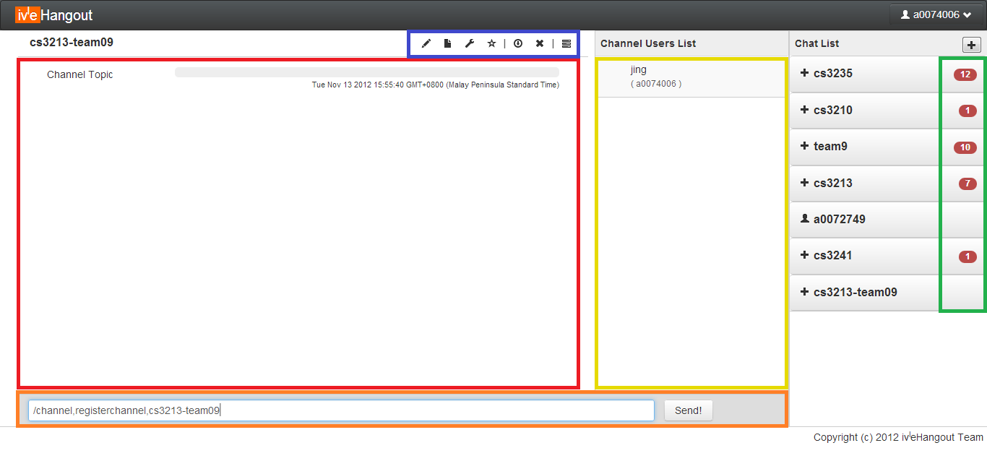

User access levels are also reflected in the user list. The “eye” icon (**Figure 11**) indicates admin and co-admin. If it is a member of the channel, it will have a human like shape. If it is a guest/visitor of the channel, it will have no icon as shown in **Figure 10**.

Figure

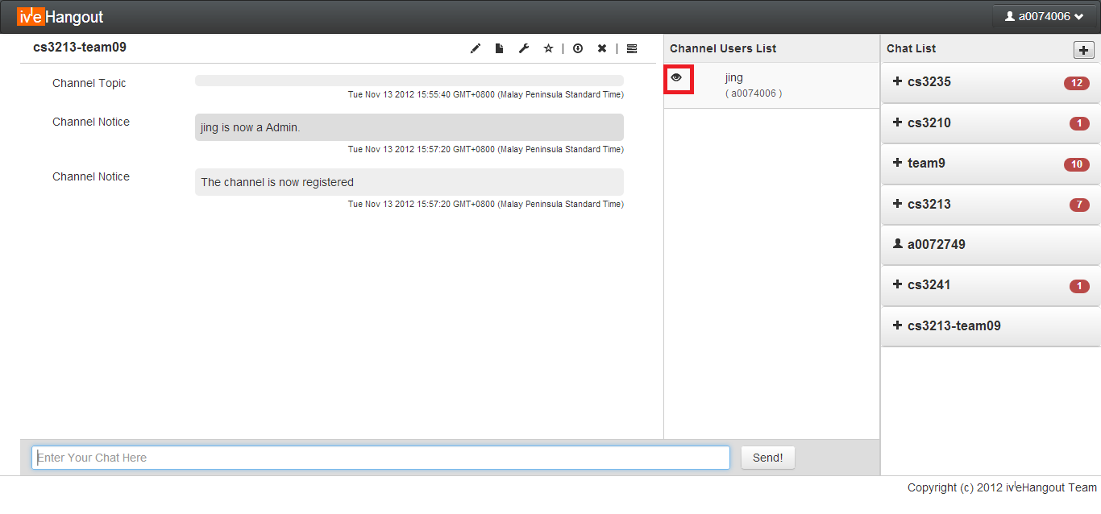

### The Dashboard – Canvas

This is a special feature that allow different user to draw on a selected area. It will display the drawing in real time across all the users in the channel. A description of **Figure 12** is as follows:

1. Highlighted in **red** is the set of option a user can choose.
2. Highlighted in **blue** is the area the user can draw.
3. Users can also download a copy of the canvas screenshot.

Figure

### 

### The Dashboard – Files in a Channel

This is another special feature that allows different user to shares files within the channel. User will be able to upload his/her files as well as see all other files that are uploaded by other user of that channel. A description of **Figure 13** is as follows:

1. Highlighted in **red** is where the user can choose which file to upload by clicking on the “Choose File” button. A regular window file selection pop up will appear. After which, the user can click on the “Upload” button to upload the file to server.
2. Highlighted in **yellow** is where the files pertaining to the current channel are displayed.
3. Highlighted in **green** contained information such as the file name, the user id that uploaded the files and an “x” button to delete the file.

Figure

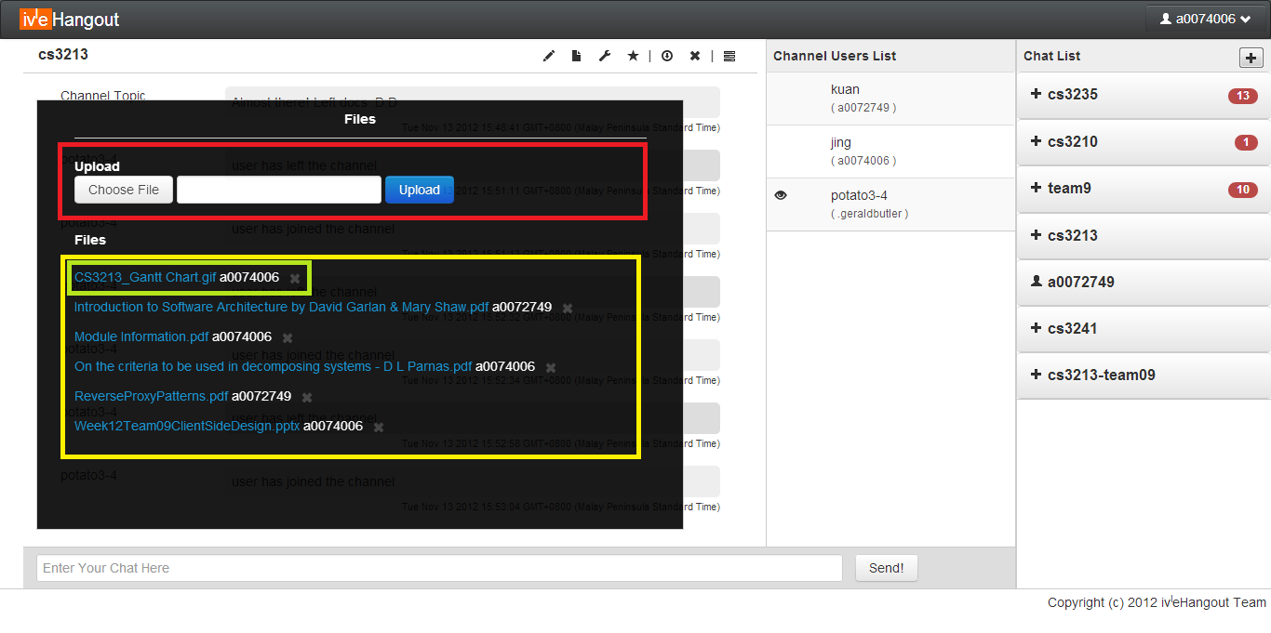

### The Dashboard – Settings of a Channel

Allow the user to view the topic as well as changing the topic (if permission granted by channel admin). A description of **Figure 14** is as follows:

1. Highlighted in **yellow**, is where the user can change the topic pertaining to the channel.
2. Highlighted in **red**, is shows the overall information pertaining to the channel. (More details can be added in the future such as Channel admin/co-admin as well as Channel access level.

Figure

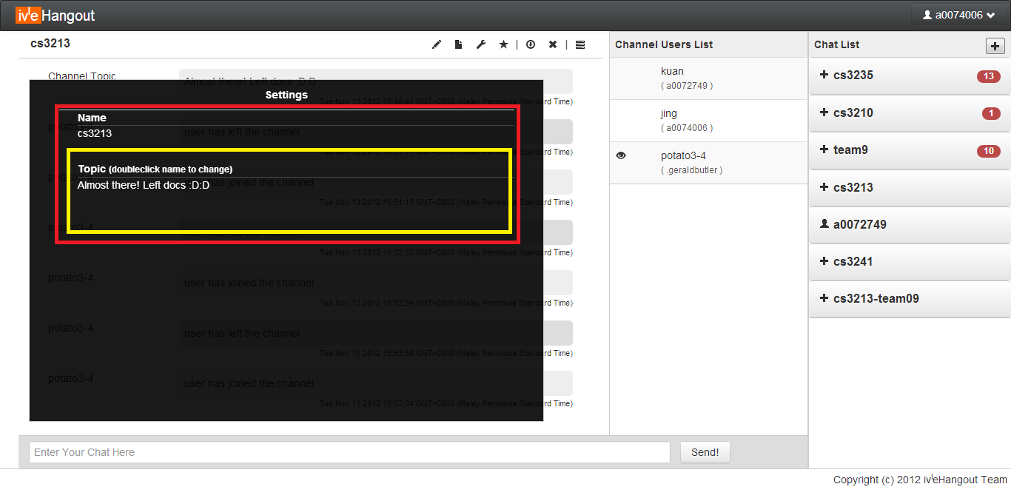

### The Dashboard – Favourite (Bookmark) a Channel

This feature allows the user to set a particular channel as default/auto join channel upon login. A description of **Figure 15** is as follows:

1. Highlighted in **red**, is the star icon that is shaded indicates that the channel is set to be a default/auto join channel. A notification will be shown as highlighted in **red** at the bottom right of the screen. If the star icon is not shaded, it indicates that the channel is either not set to be default/auto join channel or it has been removed from the user default/auto join channel.

Figure

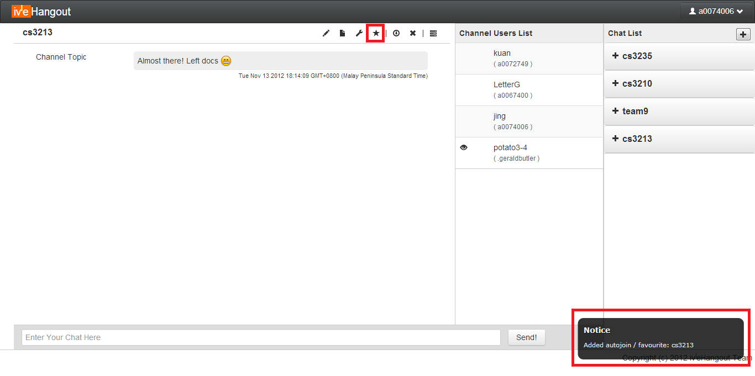

### The Dashboard – Saving the Chat Log

This is a chat log function that allows the user to save the chat history pertaining to the current selected channel/private chat. A description of **Figure 16** is as follows:

1. Highlighted in **red**, is a windows pop up file selection. This is where the user can choose to save its chat history file.
2. Highlighted in **blue** is the channel name, the name of the file will be automatically set to be the channel name. Nonetheless, the user is allowed to change the file name.

Figure

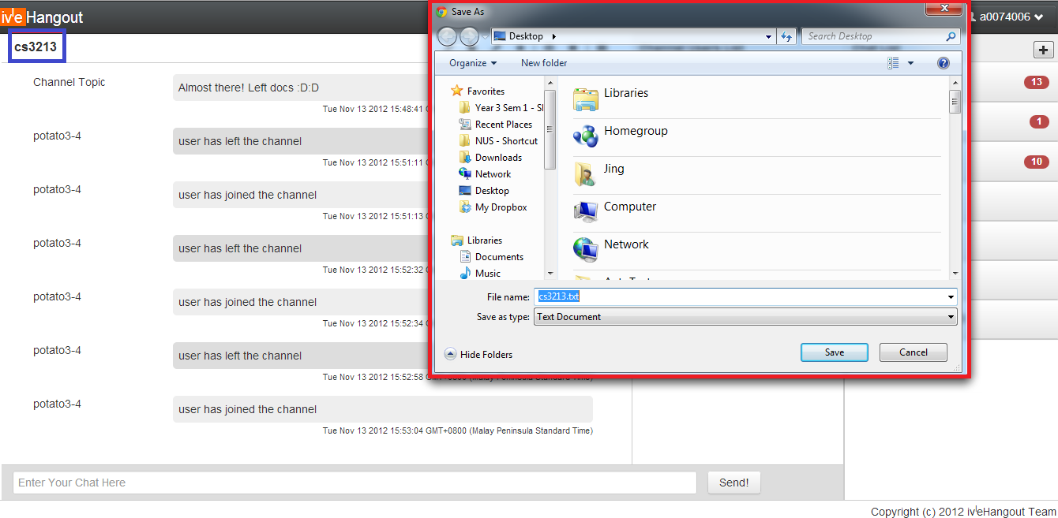

### The Dashboard – Closing a Channel

This is to close the current channel to stop receiving messages from the channel. User can simply click on the button highlighted in **red** in **Figure 17** to close the channel.

Figure

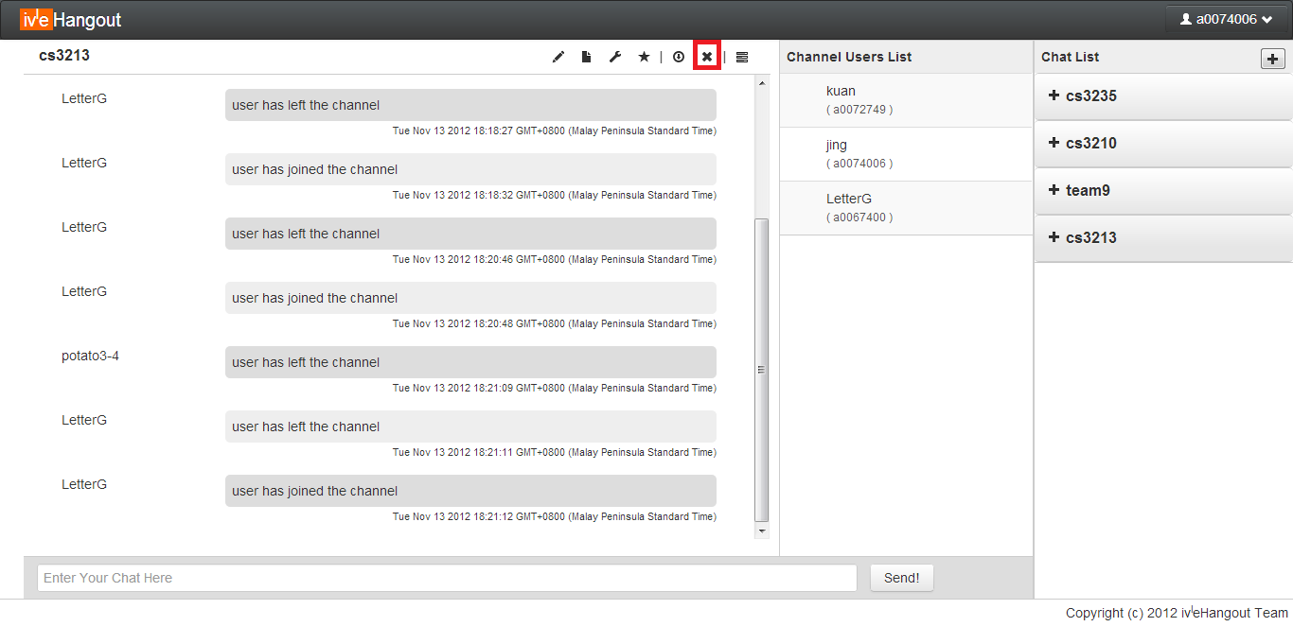

### The Dashboard – Channel User List

Upon clicking this icon, user is able to minimum the user list (highlighted in **yellow**) and at the same time maximizing the chat area (highlighted in **red**).

Figure

